DBMS

LAB ASSIGNMENT - 4



Ananya Agarwal

102083036

2CO14

**QUES 1: Use the following functions**

1. chr (n):

**code:**

select chr(65) from dual;

**screenshot:**

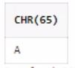

1. cancat(char1,char2):

**code:**

select concat('Ananya',' Agarwal') from dual;

**screenshot:**

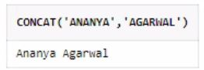

1. instr(string,char):

**code:**

select instr('Ananya','nya') from dual;

**screenshot:**

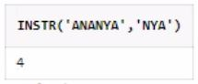

1. length(n):

**code:**

select length('Ananya') from dual;

**screenshot:**

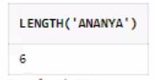

1. lpad(char1 ,n [,char2]):

**code:**

select lpad('Ananya',10,'Hie ') from dual;

**screenshot:**

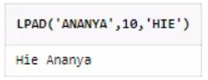

1. ltrim(string [,char(s)]):

**code:**

select ltrim('Ananya','An') from dual;

**screenshot:**

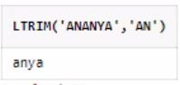

1. rpad(char1 ,n [,char2]):

**code:**

select rpad('Ananya',15,' Agarwal ') from dual;

**screenshot:**

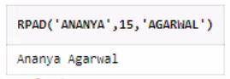

1. rtrim(string [,char(s)]):

**code:**

select rtrim('Ananya!!','!!') from dual;

**screenshot:**

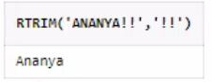

1. replace(char ,search_string , replacement_string):

**code:**

select replace('adefcate','ef','vo') from dual;

**screenshot:**

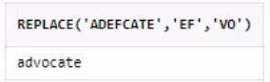

1. substr(string ,position ,substring length):

**code:**

select substr('AAnanyaagarwal',2,6) from dual;

**screenshot:**

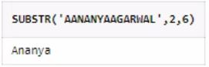

1. initcap(char):

**code:**

select initcap('ananya agarwal') from dual;

**screenshot:**

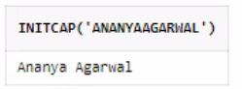

1. lower(string):

**code:**

select lower('Ananya') from dual;

**screenshot:**

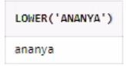

1. upper(string):

**code:**

select upper('Ananya') from dual;

**screenshot:**

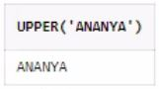

1. translate(char ,from string ,to string):

**code:**

select translate('Hie how are you!!','ho','ty') from dual;

**screenshot:**

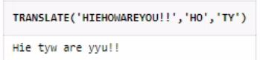

1. abs(n):

**code:**

select abs(-100) from dual;

**screenshot:**

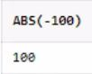

1. ceil(n):

**code:**

select ceil(64.234) from dual;

**screenshot:**

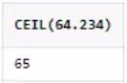

1. cos(n):

**code:**

select cos(60*3.142857142857143/180) from dual;

**screenshot:**

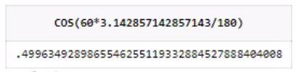

1. exp(n):

**code:**

select exp(1) from dual;

**screenshot:**

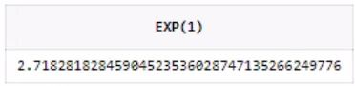

1. floor(n):

**code:**

select floor(64.234) from dual;

**screenshot:**

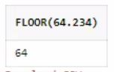

1. mod(m ,n):

**code:**

select mod(5 ,2) from dual;

**screenshot:**

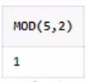

1. power(x ,y):

**code:**

select power(2 ,5) from dual;

**screenshot:**

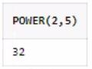

1. round(x [,y]):

**code:**

select round(34.567,0) from dual;

**screenshot:**

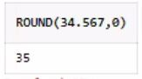

1. sign(n):

**code:**

select sign(1) from dual;

**screenshot:**

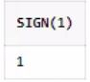

1. sqrt(n);

**code:**

select sqrt(3) from dual;

**screenshot:**

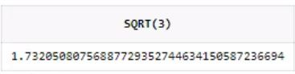

1. trunc(x ,n):

**code:**

select trunc(24.789, 1) from dual;

**screenshot:**

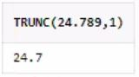

1. sysdate:

**code:**

select to_char(sysdate,'HH:MI:SS') from dual;

**screenshot:**

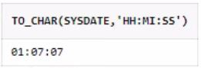

1. add_months(d ,n):

**code:**

select add_months('28-Mar-2021',6) from dual;

**screenshot:**

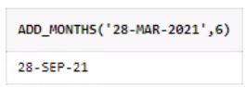

1. last_day():

**code:**

select last_day('23-Mar-2021') from dual;

**screenshot:**

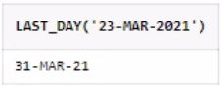

1. months_between(date1 ,date2):

**code:**

select months_between ('2-May-21' ,'3-March-21') from dual;

**screenshot:**

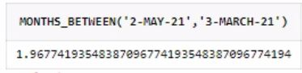

1. next_day(date ,char):

**code:**

select next_day('28-Mar-21' , 'Thur') from dual;

**screenshot:**

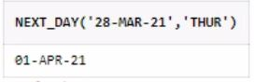

1. greatest(expr):

**code:**

select greatest(32,4,56,22) from dual;

**screenshot:**

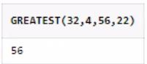

1. least(expr):

**code:**

select least('Zyx','Ananya') from dual;

**screenshot:**

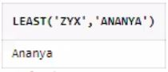

**QUES 2:** Display current time in hour : min : sec format

**Code:** select to_char(sysdate,'HH:MI:SS') from dual;



**emp table**

create table emp(empno number, ename varchar2(20),job varchar2(20), sal float,

commission float);

C:\Users\User\Desktop\1.PNG

insert into emp values(1,'Raj','Salesperson',20000,500);

insert into emp values(2,'Sham','Clerk',35000,1000);

insert into emp values(3,'abhivansh','CEO',120000,15000);

insert into emp values(4,'Ram','Manager',90000,9000);

insert into emp values(5,'Ananya','Assistant Manager',80000,7000);

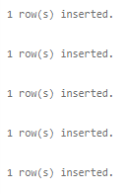

**QUES 3:** Display salary + commission of emp table.

**Code:** select sal + commission "total" from emp;

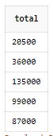

**QUES 4:** Store any date value in hiredate column of table ?

**Code:** alter table emp add hiredate date;

C:\Users\User\Desktop\4.PNG

update emp set hiredate = '20-Feb-1985' where empno = 1;

update emp set hiredate = '1-Jan-2021' where empno = 2;

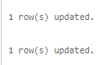

**QUES 5:** Display name of employee(s) who join the company in 1985 ?

**Code:** select ename from emp where to_char(hiredate,'YYYY') = 1985;

C:\Users\User\Desktop\6.PNG

**QUES 6:** Display name of the employee(s) who join the company this year ?

**Code:** select ename from emp where to_char(hiredate,'YYYY') = to_char(sysdate,'YYYY');

C:\Users\User\Desktop\7.PNG